Nithin S
221IT085

IT253 Lab Assignment 3

Simulation of CPU Scheduling
(Non-Preemptive)

First Come First Server [ FCFS ]

CODE

#include <stdio.h>

struct Process
{
int pid;
int AT;
int BT;
int CT;
int TAT;
int WT;
};

void sortOnAT(struct Process *processes, int size)
{
int i, j;
struct Process tmp;

for (i = 0; i < size - 1; i++)
{
for (j = 0; j < size - i - 1; j++)
{
if (processes[j].AT > processes[j + 1].AT)
{

tmp = processes[j];
processes[j] = processes[j + 1];
processes[j + 1] = tmp;
}
}
}
}

void sortOnPID(struct Process *processes, int size)
{
int i, j;
struct Process tmp;

for (i = 0; i < size - 1; i++)
{
for (j = 0; j < size - i - 1; j++)
{
if (processes[j].pid > processes[j + 1].pid)
{

tmp = processes[j];
processes[j] = processes[j + 1];
processes[j + 1] = tmp;
}
}
}
}

int main()
{
int n;
printf("Enter the number of processes:");
scanf("%d", &n);

struct Process processes[n];

printf("Enter the details of processes:\n");

for (int i = 0; i < n; i++)
{
printf("Process %d:\n", i + 1);
printf("Enter the PID: ");
scanf("%d", &processes[i].pid);
printf("Enter the Arrival Time: ");
scanf("%d", &processes[i].AT);
printf("Enter the Burst Time: ");
scanf("%d", &processes[i].BT);
printf("\n");
}

sortOnAT(processes, n);

int ct_previous = 0;
ct_previous += processes[0].AT;
int avg_TAT = 0;
int avg_WT = 0;

for (int i = 0; i < n; i++)
{
ct_previous += processes[i].BT;
processes[i].CT = ct_previous;
processes[i].TAT = processes[i].CT - processes[i].AT;
processes[i].WT = processes[i].TAT - processes[i].BT;
if (ct_previous < processes[i + 1].AT)
{
int t = processes[i + 1].AT - ct_previous;
ct_previous += t;
}
avg_TAT += processes[i].TAT;
avg_WT += processes[i].WT;
}
sortOnPID(processes, n);
printf("\nProcess\tAT\tBT\tCT\tTAT\tWT\n");

for (int i = 0; i < n; i++)
{
printf("%d\t%d\t%d\t%d\t%d\t%d\n", processes[i].pid, processes[i].AT, processes[i].BT,
processes[i].CT, processes[i].TAT, processes[i].WT);
}

printf("\nAverage Turn Around Time: %.2f", (float)avg_TAT / n);
printf("\nAverage Waiting Time: %.2f", (float)avg_WT / n);

return 0;
}

OUTPUT

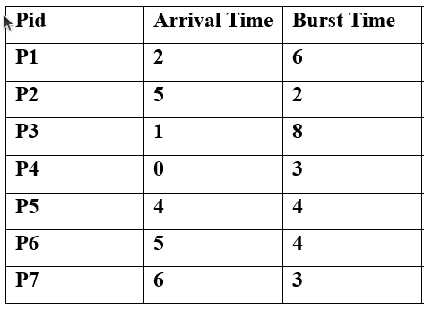
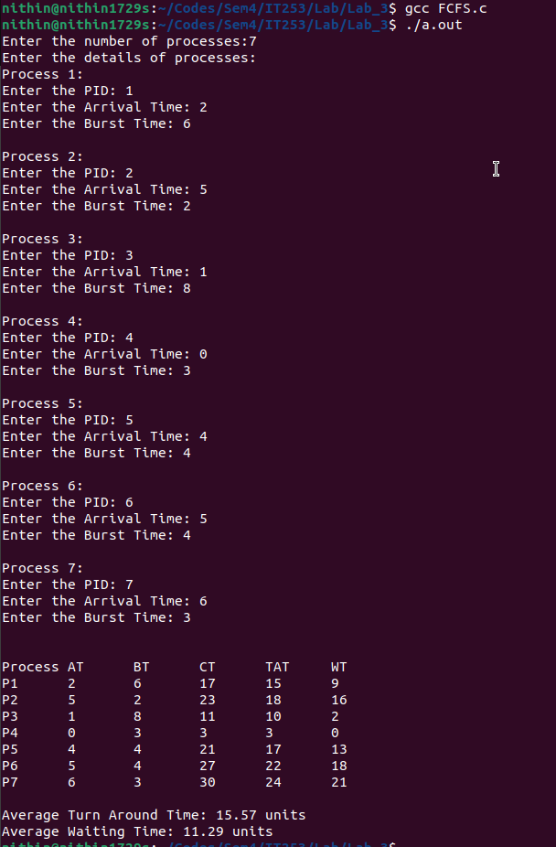

Shortest Job First [ SJF ]

CODE

#include <stdio.h>
#include<stdbool.h>

struct Process
{
int pid;
int AT;
int BT;
int Priority;
int CT;
int TAT;
int WT;
bool visited;
};

int main()
{
int n;
printf("Enter the number of processes:");
scanf("%d", &n);

struct Process processes[n];

printf("Enter the details of processes:\n");

for (int i = 0; i < n; i++)
{
printf("Process %d:\n", i + 1);
printf("Enter the PID: ");
scanf("%d", &processes[i].pid);
printf("Enter the Arrival Time: ");
scanf("%d", &processes[i].AT);
printf("Enter the Burst Time: ");
scanf("%d", &processes[i].BT);
processes[i].visited=false;
printf("\n");
}

int i,j;
int minCT=0;
for(j=0;j<n;)
{
int minBT,idx;
minBT=idx=1e9;
for(int i=0;i<n;i++)
{
if(processes[i].visited==false)
{
if(minCT>=processes[i].AT && minBT>processes[i].BT)
{
minBT=processes[i].BT;
idx=i;
}
else if(minCT>=processes[i].AT && minBT==processes[i].BT)
{
if(processes[idx].AT>processes[i].AT)
{
minBT=processes[i].BT;
idx=i;
}
}
}
}

if(idx==1e9)
{
minCT++;
}
else
{
minCT+=minBT;
processes[idx].visited=true;
processes[idx].CT=minCT;
j++;
}
}
int avg_TAT=0;
int avg_WT=0;
for(int i=0;i<n;i++)
{
processes[i].TAT=processes[i].CT-processes[i].AT;
processes[i].WT=processes[i].TAT-processes[i].BT;
avg_TAT+=processes[i].TAT;
avg_WT+=processes[i].WT;
}

printf("\nProcess\tAT\tBT\tCT\tTAT\tWT\n");

for (int i = 0; i < n; i++)
{
printf("P%d\t%d\t%d\t%d\t%d\t%d\n", processes[i].pid, processes[i].AT, processes[i].BT,
processes[i].CT, processes[i].TAT, processes[i].WT);
}

printf("\nAverage Turn Around Time: %.2f", (float)avg_TAT / n);
printf("\nAverage Waiting Time: %.2f\n", (float)avg_WT / n);

return 0;
}

OUTPUT
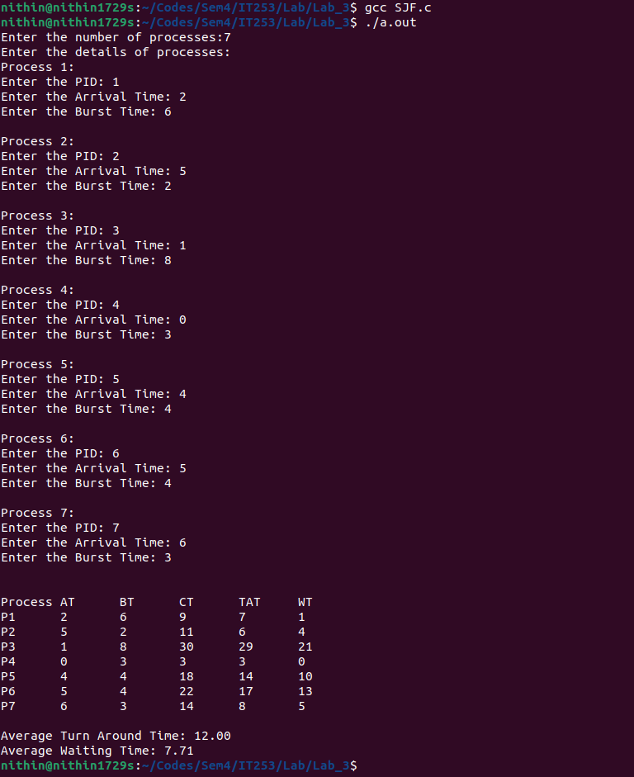

Priority

CODE

#include <stdio.h>
#include<stdbool.h>

struct Process
{
int pid;
int AT;
int BT;
int Priority;
int CT;
int TAT;
int WT;
bool visited;
};

int main()
{
int n;
printf("Enter the number of processes:");
scanf("%d", &n);

struct Process processes[n];

printf("Enter the details of processes:\n");

for (int i = 0; i < n; i++)
{
printf("Process %d:\n", i + 1);
printf("Enter the PID: ");
scanf("%d", &processes[i].pid);
printf("Enter the Arrival Time: ");
scanf("%d", &processes[i].AT);
printf("Enter the Burst Time: ");
scanf("%d", &processes[i].BT);
printf("Enter the Priority: ");
scanf("%d", &processes[i].Priority);
processes[i].visited=false;
printf("\n");
}

int i,j;
int minCT=0;
for(j=0;j<n;)
{
int minBT,idx;
minBT=idx=1e9;
for(i=0;i<n;i++)
{
if(processes[i].visited==false)
{
if(minCT>=processes[i].AT && minBT>processes[i].Priority)
{
minBT=processes[i].Priority;
idx=i;
}
else if(minCT>=processes[i].AT && minBT==processes[i].Priority)
{
if(processes[idx].AT>processes[i].AT)
{
minBT=processes[i].Priority;
idx=i;
}
}
}
}

if(idx==1e9)
{
minCT++;
}
else
{
minCT+=processes[idx].BT;
processes[idx].visited=true;
processes[idx].CT=minCT;
j++;
}
}
int avg_TAT=0;
int avg_WT=0;
for(int i=0;i<n;i++)
{
processes[i].TAT=processes[i].CT-processes[i].AT;
processes[i].WT=processes[i].TAT-processes[i].BT;
avg_TAT+=processes[i].TAT;
avg_WT+=processes[i].WT;
}

printf("\nProcess\tAT\tBT\tPr\tCT\tTAT\tWT\n");

for (int i = 0; i < n; i++)
{
printf("P%d\t%d\t%d\t%d\t%d\t%d\t%d\n", processes[i].pid, processes[i].AT, processes[i].BT,processes[i].Priority,
processes[i].CT, processes[i].TAT, processes[i].WT);
}

printf("\nAverage Turn Around Time: %.2f units", (float)avg_TAT / n);
printf("\nAverage Waiting Time: %.2f units\n", (float)avg_WT / n);

return 0;
}

OUTPUT

